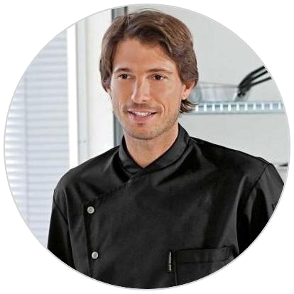

PERSONAL INFO
DOB: 22/05/1990
Nationality: French
Passport: EU
Visa Info: C1/D
Seaman’s Book: Yes
marinecv@gmail.com

+386 2458 9875
Skype:

Antibes, France

SKILL SETS


French cuisine


Mid Eastern cuisine


Vegan food Fusion


Sweets/pastry


Baking,pastry, butchery, fish mongering, molecular gastronomy and pasta making

LANGUAGES

English


French

QUALIFICATIONS


STCW
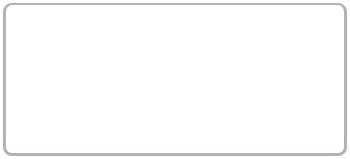

Medical First Aid STCW Basic Safety Training
Security Awarn.

Jean Dubois


Professional Title

Short and engaging pitch about yourself.

WORK EXPERIENCE

Title/Position
Workplace/Company

10/2015 – Present | 70m

Company
Tasks
Length of the vessel

Working as a Sole Chef for a private and charter yacht providing 5* food contracted until 4th September based en, also providing dietary, allergen needs and catering for specific cultural requirements

Contact for Reference: Capt. Andreas Ianou – +357 25 25 478 32 - attachment button to upload

Chef
M/Y "Just One"

05/2014 – 11/2014 |  | 50m
Company
Length of the vessel
 | Cooking for 15 crew and assistant Head chef during charter and owner trips.
Contact for Reference: Mr. Nikos Papadopolous (Crew Manager) – +380 5478 6521 521 - attach

Relief Chef
M/Y "Sunset"

11/2012 – 01/2013 |  | 60m
IPY Cruise
Tasks
 | Relief Chef-Cooking for 13 crew and Assistant Head Chef during owner trip
Contact for Reference: Ms. Dimitra Smith – +350 1247 879 25 - attachment button to upload the Letter

Crew Chef
M/Y "Only You"

04/2011 – 09/2012 | 45m
IPY Cruise

Tasks

Busy charter yacht • Cooking for 7 crew and 4 to 12 guests. Very very busy private yacht with gluten free, healthy meal and menu for kids. Buﬀet style for lunch and 3 courses for dinner.

Contact for Reference: Capt. Alex John – + 382 124 8759 56 - attachment button to upload

REFFERENCES

Reference: (Name), (Rank), (Phone), (Email) - attachment button

